Table of Contents
Lab 1: Introduction to Operating System (OS) & Command Prompt (CMD) 2
Introduction 2
Examples of Operating System 2
Advantages of OS 2
Basic Commands 3
Lab 2: Basic CMD Commands for Directory Management 5
What is CMD 5
Why We Use CMD 5
Basic CMD Commands 5
Lab 3: Creating Folders 7
Making a Folder For Books 7
Lab 4: Doing Tasks Using CMD 8
Folder Managements Using DOS 8
Removing a Folder With Subfolders 8
Executing Multiple Commands On Desktop 9
Lab 5: Advanced File and Directory Management in CMD 10
Directory Navigation And Creation 10
File Operations 10
File Replacement and Printing 11
Managing System Date & Deleting Files 11
File and Folder Management 12
File Replacement and Cleanup 12
Lab 6: Managing File Operations Using CMD 10
Directory Navigation And Creation 10
File Operations 10
File Replacement and Printing 11
Managing System Date & Deleting Files 11

Lab 1: Introduction To Operating System
Introduction
An Operating System (OS) is system software that manages computer hardware and software resources and provides common services for computer programs. It acts as an intermediary between users and the computer hardware.
Examples of Operating Systems:
- Windows: Developed by Microsoft (e.g., Windows 10, 11)
- macOS: Developed by Apple for Mac computers
- Linux: Open-source OS (e.g., Ubuntu, Fedora)
- Android: Mobile OS developed by Google
- iOS: Apple's mobile operating system

Why We Use OS
An OS is essential for the following reasons:
- Resource Management: Manages CPU, memory, storage, and input/output devices.
- User Interface: Provides a way for users to interact with the system (GUI or CLI).
- Program Execution: Runs applications efficiently.
- File Management: Organizes and controls access to data stored on drives.
- Security: Protects data and prevents unauthorized access.

Advantages of OS
- Multi-tasking: Runs multiple applications simultaneously.
- User-Friendly Interface: Provides GUI-based interaction (Windows, macOS).
- Hardware Management: Controls and optimizes the use of CPU, RAM, and peripherals.
- Networking: Enables internet and local network connectivity.
- Security Features: Includes firewalls, user authentication, and encryption.

Basic Commands
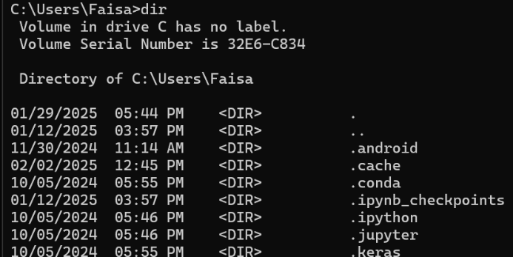
- dir: Lists files and folders in the current directory.

- cd [folder]: Changes the directory.
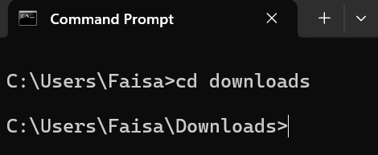

- cd .. : Moves up one directory.
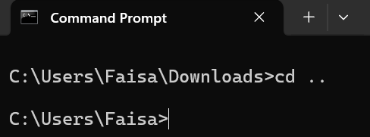

- mkdir [folder]: Creates a new folder.
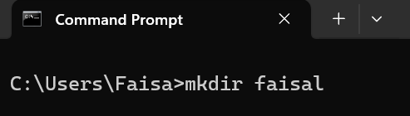

- rmdir [folder]: Deletes a folder.
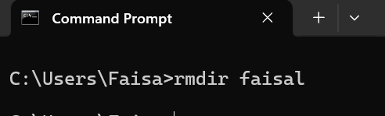

- cls: Clears the screen.
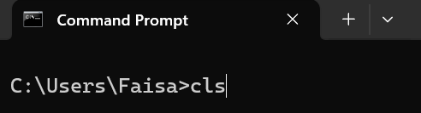

- echo [text]: Displays text on the screen.
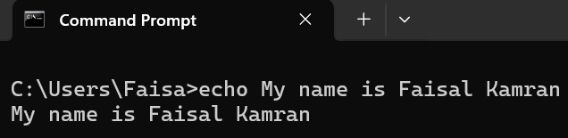

- exit: Closes CMD
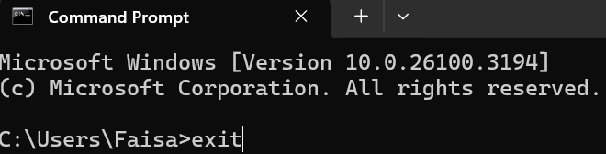

Lab 2: Implementation Of Basic CMD Commands
What is CMD?
CMD (Command Prompt) is a command-line interpreter in Windows OS that allows users to execute commands directly by typing them. It provides direct access to system functions, enabling file management, troubleshooting, and automation.

Why We Use CMD
- System Administration: Manage files, directories, and processes.
- Automation: Run scripts to automate repetitive tasks.
- Networking: Troubleshoot and configure network settings.
- Accessing Hidden Features: Perform system-level operations not available in the GUI.

Basic CMD commands
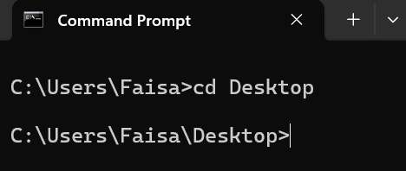
- cd: The cd command is used to change the directory.

- md: The md commands is used to make new directory
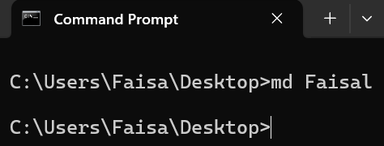

- rd: The rd commands is used to remove a directory
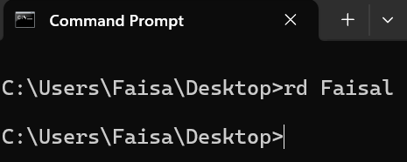

- ren: The ren commands is used to rename a directory
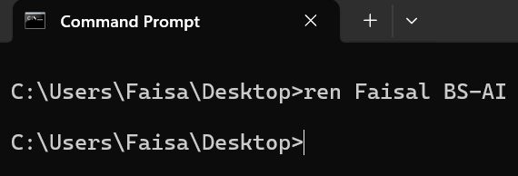

- Create multiple folders: To Create multiple folders we use md command with /
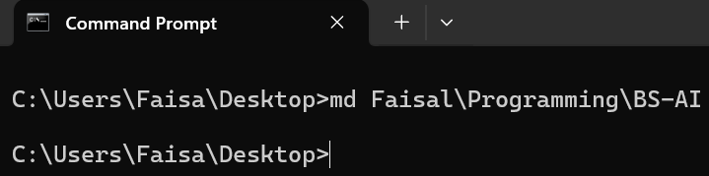

Lab 3: Making Folders Using CMD
Making a Folder for Books
- We are making a folder for books with Books being main folder
- There are 3 folders in Books named Math’s, Computer and Physics
- Computer Folder has 2 subfolders Trigonometry and Calculus
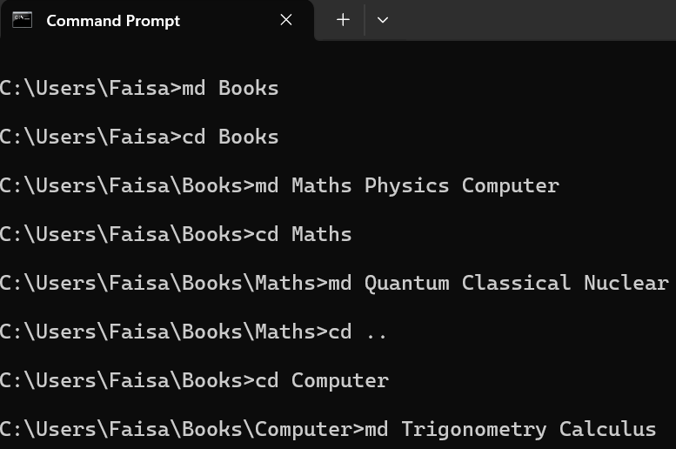
- Math’s Folder has 3 subfolders Quantum, Classical and Nuclear

Lab 4: Doing Tasks Using CMD
Folder Management Using DOS
- Navigate to Desktop and create a folder named TestFolder
- Inside TestFolder create a sub folder a SubFolder1
- Hide SubFolder1
- Unhide SubFolder1 and make it visible again
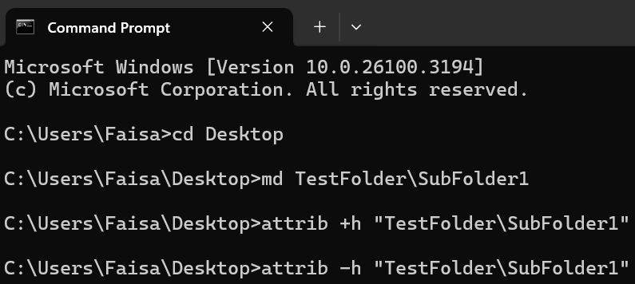

Removing a Folder with Subfolders
- Navigate to Desktop and create a folder named DeleteMe
- Inside DeleteMe create two sub folders Sub1 and Sub2
- Use the rmdir command with /s to delete the folder and subfolders
- Use dir command to check whether it still exists or not
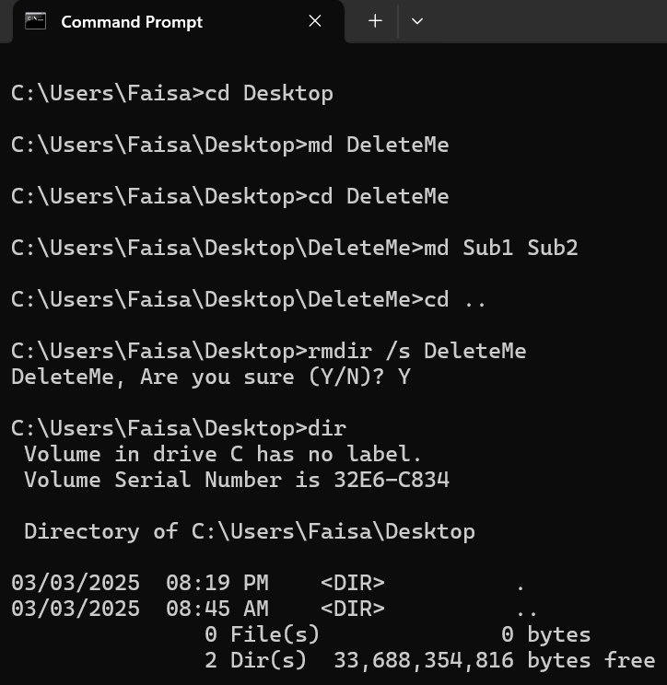

Executing Multiple Commands on Desktop
- Execute dir command
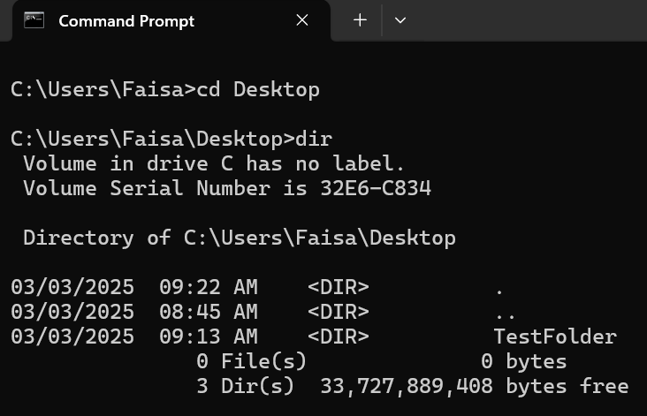


- Execute tree command
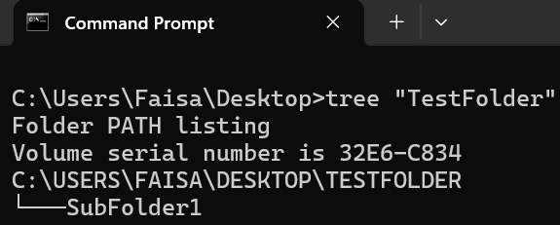

- Make E current directory
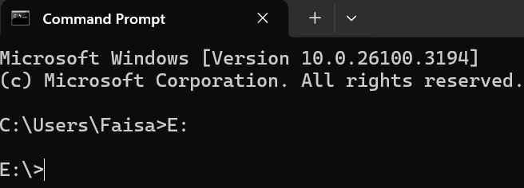

- Hide and Unhide a file
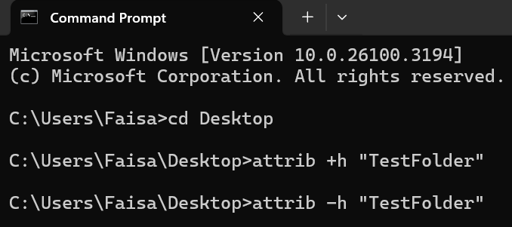

Lab 5: Advanced File and Directory Management in CMD
Directory Navigation And Creation
- Open Command Prompt (cmd).
- Navigate to the Desktop:
- Create a folder named "ProjectLab" with subfolders "Docs", "Source", and "Backup":
- Verify the structure using tree command
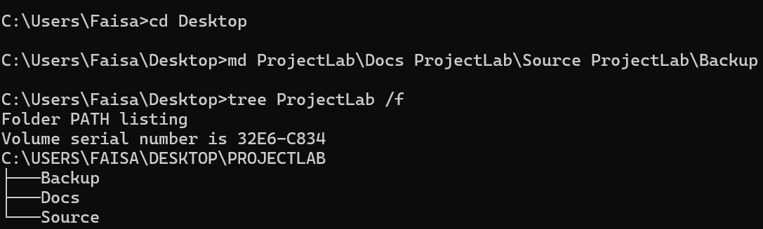

File Operations
- Create a sample text file in "Docs":
- Create a text file named report.txt with the following text: “This is a sample document”
- Rename "report.txt" to "summary.txt":
- Move "summary.txt" to "Backup"
- Verify the updated structure: tree command
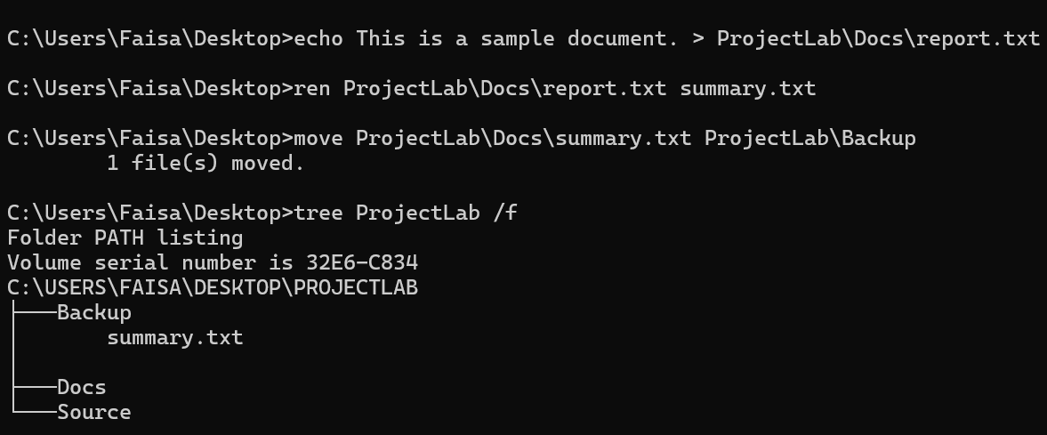

Managing System Date & Deleting Files
- Display the current system date:
- Delete "summary.txt" from "Backup"
- Remove the entire "ProjectLab" folder and its contents
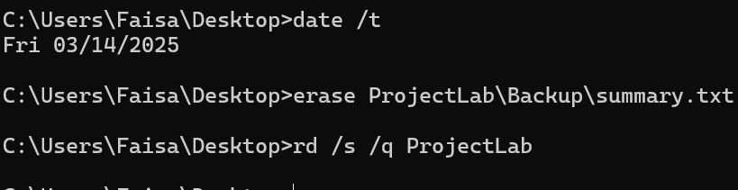

Navigate to the Desktop.
- Create a folder named "WorkProject".
- Inside "WorkProject", create two subfolders: "Docs" and "Source".
- In the "Docs" folder, create a text file named "report.txt" and write "Initial Report" inside it.
- Rename "report.txt" to "final_report.txt".
- Move "final_report.txt" from "Docs" to the "Source" folder.
- Display the folder structure of "WorkProject" to verify the changes.
- Delete the "Docs" folder after ensuring it is empty.
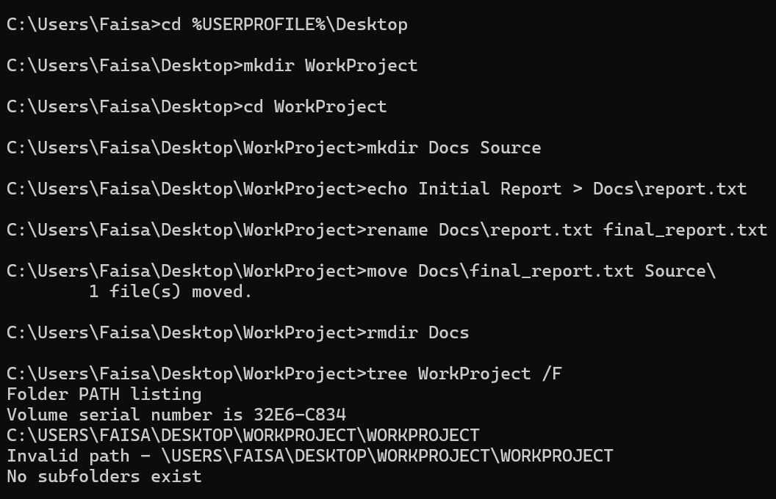

File Replacement and Printing
- Create another text file in "Source":
- Write the following text “This is version 1 of the file”
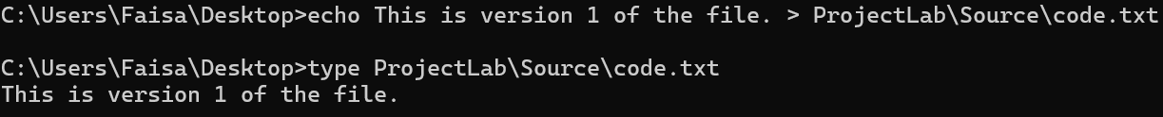
- Print the contents of "code.txt":

File Replacement and Cleanup
- Inside the "Source" folder, create a file named "draft.txt" and write "This is the first version." inside it.
- In the "WorkProject" folder, create a new file named "update.txt" and write "This is the final version." inside it.
- Replace "draft.txt" in "Source" with the updated file "update.txt".
- Print the contents of the updated file to verify the replacement.
- Check the system's current date.
- Delete "update.txt" from "WorkProject" (since it has been copied to "Source").
- Delete the entire "WorkProject" folder and its contents.
- Verify that "WorkProject" no longer exists.
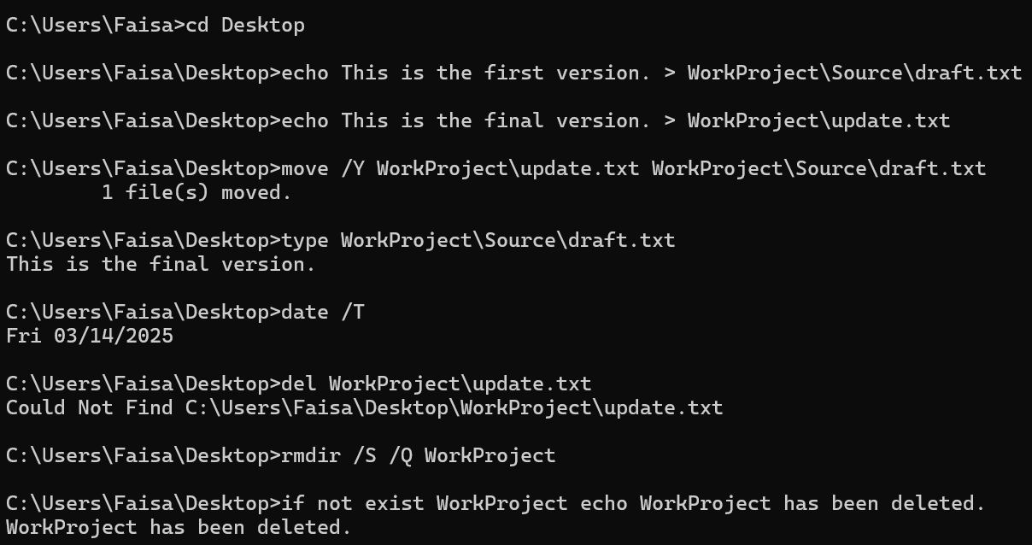

Lab 6: Managing File Operations Using CMD
Creating and Managing Files
Our goal is to create Word, Notepad, and PowerPoint files, then view the file structure.
Steps:
- Navigate to the Desktop:
- Create an empty Word file:
- Create a Notepad file with content:
- Create an empty PowerPoint file
- View the folder structure
Expected Outcome is three files (Document.docx, Notes.txt, Presentation.pptx) created and visible in CMD.
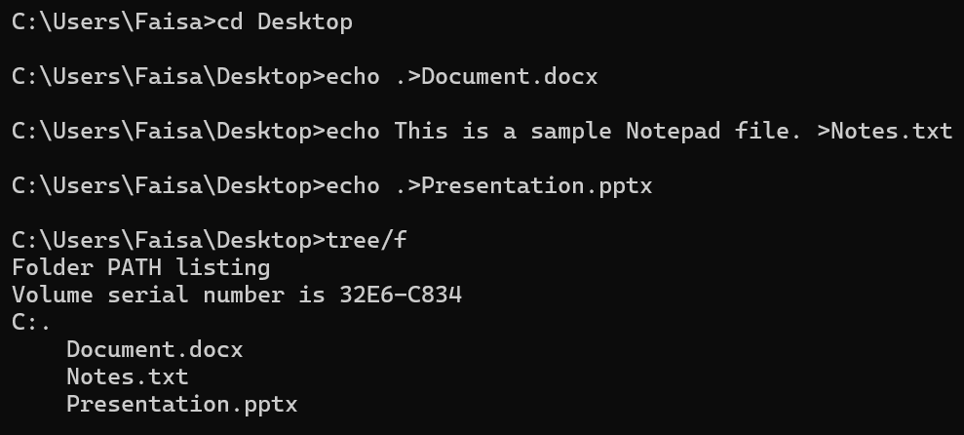

Opening, Replacing, and Closing Files
Our goal is to open files, replace an existing file, and close an open fileSteps:
- Open the Word document
- Open the Notepad file
- Replace the Notepad file with a new version
- Close Notepad without saving
- Verify the replacement
Expected Outcome is Notepad file content should be updated and Notepad should be closed forcefully.

